

Forecasting module

Documentation

V3.2

Document Released: May 26, 2016

frePPLe bvba  
Woluwestraat 17  
1930 Zaventem  
http://frepple.com

**Table of Contents**

1. Introduction 4

1. Functional overview 4

a. Data loading 4

b. History correction 5

c. Baseline forecast generation 5

d. Aggregation disaggregation process 7

e. Forecast review 10

f. Forecast profiling 10

g. Forecast consumption 11

2. User guide 11

a. Forecast report 12

b. Forecast editor 13

c. Distribution planning screen 15

3. Modelling and configuration 15

a. Input table Forecast 15

b. Input table ForecastDemand 16

c. Output table ForecastPlan 16

d. Forecasting parameters 16

**The COMPLETE content of this DOCUMENT Is   
under copyright of frePPLE bvba.**

**distRIBUTIOn of this document is not allowed   
without explicit authorization from frePPLe BVBA.**

# Introduction

This document describes the forecasting module of frePPLe.

This module support the calculation of forecasted demand, their management and review of these values by planners and sales people, and the pre-processing of the forecast.

# Functional overview

A forecasting process typically consists of the following sub processes.

1. Data loading
2. History correction
3. Baseline forecast generation
4. Forecast review and editing
5. Forecast profiling
6. Forecast consumption

## Data loading

In a first step the input data are loaded into the frePPLe database. The key input consists of the following data elements:

* Items and their hierarchy.
* Customers and their hierarchy.
* Locations and their hierarchy.
* Forecast, which defines a combination of a customer, a location and an item where forecast calculations are stored and performed.
* Historical demand.

In most implementations these data elements are all loaded automatically through data interfaces from external systems. No manual intervention by the planner is then required for this step.

## History correction

The demand history may contain some exception, one-off demands which are often called “demand outliers”. In order to avoid that such demand influence the calculation of the statistical forecast in the next step too much, the planner should review the recent demand buckets for such exceptional demands and correct them.

Here are some typical situations where such corrections are required:

* + Exceptional demands, aka outliers
  + Product revisions, sku1 -> sku2 -> sku3

Note that the calculation of the baseline forecast has a built-in threshold correction for demand outliers. This feature takes care of some demand outliers which weren’t corrected by the planner, but can never achieve the same quality as review and analysis by the planner.

## Baseline forecast generation

In this step the system will apply statistical techniques on the demand history and extrapolate it into the future buckets. This generates automatically a **baseline forecast**.

These calculations are fully automated, and no planner intervention is required in this step.

The following time series forecasting techniques are implemented:

* **Moving average – constant forecast**  
  This methods uses the average of the last N buckets as the forecast for each future period.  
  FrePPLe will automatically use this technique if the time series doesn’t contain enough values to apply any of the techniques that follow.
* **Single exponential smoothing – constant forecast**  
  This technique assigns exponentially decreasing weight on the previous demand buckets: the most recent time bucket gets weight 1-α, the bucket before, the bucket before , and so on. The average of this weighted demand in these buckets is used as the forecast for each future period.  
  FrePPLe will automatically select the value of the parameter α to achieve the lowest deviation between the forecast and actual demand.
* **Double exponential smoothing – trending forecast**This method is similar to the previous one, but also computes a trending component.The algorithm will automatically tune the constant α and trend β parameters of this forecasting method to minimize the forecast error.
* **Holt-Winters multiplicative triple exponential smoothing – seasonal demand**FrePPLe performs a covariance check to detect seasonal patterns for each of the cycle lengths in the configured range.  
  When a seasonal pattern is detected and sufficient historical data are available, frePPLe computes a forecast with the Holt-Winters multiplicative seasonal method. The constant and trend β parameters are automatically tuned to minimize the forecast error. The seasonal parameter γ is fixed.
* **Croston’s method – intermittent demand**Croston’s forecast method will be used by frePPLe when the intermittence (ie the percentage of time buckets without demand) exceeds the configured threshold. The other methods, except from moving average, are then excluded.  
  The algorithm will automatically tune the parameter in the configured range to mimimize the forecast error.

Each of these techniques is evaluated. The method which gives the lowest forecast error is automatically chosen to compute the baseline forecast. This evaluation is based on the symmetric mean percentage forecast error (SMAPE), where the forecast error in recent buckets is weighted more than the forecast error in older buckets.

The selected method for forecasting can either be left to frePPLe that will choose the method minimizing the forecast error or selected in the forecast table.

Apart from the statistical methods described above, two other methods are also available :  
- Automatic : frePPLe will selected the method minimizing the forecast error.   
- Aggregate : The method suits well for reporting at aggregated level as the sum of the children forecast will be displayed for that Item, Customer, Location combination.

Important : Note that if the selected method for an aggregated Item, Customer, Location combination (e.g : Item1, All Locations, All Customers) is different from Aggregate, frePPLe will aggregate the children demand at that level, calculate the forecast then disaggregate the computed forecast among the children. The aggregation/disaggregation process is explained below in this document.

## Aggregation disaggregation process

There are two ways a planner can decide to forecast the demand. The forecast can either be calculated at leaf level then aggregated at parent level or calculated at parent level then disaggregated at the leaf level.

Let’s imagine a very simple hierarchy for the three dimensions Item, Customer, Location:

The first possibility is to forecast the following leaf combinations :

|  |  |  |  |  |
| --- | --- | --- | --- | --- |
| **Item** | **Location** | **Customer** | **Method** | **Node** |
| Item1 | Location1 | Customer1 | Automatic | Leaf |
| Item1 | Location1 | Customer2 | Automatic | Leaf |
| Item1 | Location2 | Customer1 | Automatic | Leaf |
| Item1 | Location2 | Customer2 | Automatic | Leaf |
| Item2 | Location1 | Customer1 | Automatic | Leaf |
| Item2 | Location1 | Customer2 | Automatic | Leaf |
| Item2 | Location2 | Customer1 | Automatic | Leaf |
| Item2 | Location2 | Customer2 | Automatic | Leaf |
| Item1 | All locations | All customers | Aggregate | Parent |
| Item2 | All locations | All customers | Aggregate | Parent |

Note that there are more parent combinations but for the sake of the example, we will only consider the two above. Note also that the Node column is not present in the forecast table, this is just for this document to quickly identify whether a combination is a leaf or a parent. FrePPLe will determine this information by itself.

FrePPLe will then aggregate the results at parent level by summing the forecast calculated at all leaves for a parent.

Item1, All locations, All customers will then have as forecast the sum of all the item1 leaves and same for Item2, All locations, All customers that will have as forecast the sum of all the Item2 leaves.

In the second option, FrePPLe provides the possibility to aggregate the demand at a parent level, calculate the forecast at this aggregated level then disaggregate the forecast over the children.

The forecast table should be populated as follow :

|  |  |  |  |  |
| --- | --- | --- | --- | --- |
| **Item** | **Location** | **Customer** | **Method** | **Node** |
| Item1 | Location1 | Customer1 | Automatic | Leaf |
| Item1 | Location1 | Customer2 | Automatic | Leaf |
| Item1 | Location2 | Customer1 | Automatic | Leaf |
| Item1 | Location2 | Customer2 | Automatic | Leaf |
| Item2 | Location1 | Customer1 | Automatic | Leaf |
| Item2 | Location1 | Customer2 | Automatic | Leaf |
| Item2 | Location2 | Customer1 | Automatic | Leaf |
| Item2 | Location2 | Customer2 | Automatic | Leaf |
| Item1 | All locations | All customers | Automatic | Parent |
| Item2 | All locations | All customers | Automatic | Parent |

The goal of such a feature is to lay out some patterns such as trend or seasonality that might not be detected at lower level.  
The aggregation disaggregation feature will be performed on any tuple having an element not being a leaf in the hierarchy (e.g : Item1, All locations, All customers or Item1, location1, All customers) with a forecast method different from Aggregate (e.g : Automatic, Seasonal, moving average…).

Let’s suppose we have the following demand history (figures in this example are just for the sake of the example):

|  |  |  |  |  |
| --- | --- | --- | --- | --- |
| **Location** | **Customer** | **Item** | **Date** | **Demand Quantity** |
| Location1 | Customer1 | Item1 | Current - 1 | 3 |
| Location1 | Customer2 | Item1 | Current -1 | 3 |
| Location1 | Customer1 | Item1 | Current - 2 | 1 |
| Location2 | Customer2 | Item1 | Current - 1 | 6 |
| Location2 | Customer1 | Item1 | Current -1 | 5 |
| Location1 | Customer2 | Item1 | Current -2 | 4 |

To aggregate the total forecast for Item1 over all locations and all customers, the planner has to populate in the Forecast table the following record. Here we assume a hierarchy exists for locations and customers with at the top of the hierarchy All locations and All customers. We also assume the planner wants frePPLe to determine the best forecasting method as the Automatic method is selected. Any other method (apart for Aggregated) could be selected to perform aggregation disaggregation.

|  |  |  |  |
| --- | --- | --- | --- |
| **Location** | **Customer** | **Item** | **Method** |
| All locations | All customers | Item1 | Automatic |

When running the forecasting process, frePPLe will internally forecast the children combinations (these values will be used for disaggregation) :

|  |  |  |  |  |
| --- | --- | --- | --- | --- |
| **Location** | **Customer** | **Item** | **Date** | **Forecast Quantity** |
| Location1 | Customer1 | Item1 | Current | 3.2 |
| Location1 | Customer2 | Item1 | Current | 3.5 |
| Location2 | Customer1 | Item1 | Current | 5.6 |
| Location2 | Customer2 | Item1 | Current | 6.3 |

FrePPLe will then compute the aggregated forecast by summing the demand history over all the children for the (All locations, All customers, Item1) combination:

|  |  |  |  |  |
| --- | --- | --- | --- | --- |
| **Location** | **Customer** | **Item** | **Date** | **Demand Quantity** |
| All locations | All customers | Item1 | Current - 2 | 1+4=5 |
| All locations | All customers | Item1 | Current-1 | 3+3+6+5=17 |

This will result into a forecast for the (All locations, All customers, Item1) combination :

|  |  |  |  |  |
| --- | --- | --- | --- | --- |
| **Location** | **Customer** | **Item** | **Date** | **Forecast Quantity** |
| All locations | All customers | Item1 | Current | 19.4 |

FrePPLe will then disaggregate the forecast at the pro-rate of the children’s computed forecast. In our example, the sum of the children forecast equals to 3.2+3.5+5.6+6.3=18.6, therefore we will have the following results :

|  |  |  |  |  |
| --- | --- | --- | --- | --- |
| **Location** | **Customer** | **Item** | **Date** | **Disaggregated Forecast Quantity** |
| Location1 | Customer1 | Item1 | Current | 3.2/18.6*19.4=3.33 |
| Location1 | Customer2 | Item1 | Current | 3.5/18.6*19.4=3.65 |
| Location2 | Customer1 | Item1 | Current | 5.6/18.6*19.4=5.84 |
| Location2 | Customer2 | Item1 | Current | 6.3/18.6*19.4=6.57 |

This example only displays current bucket but frePPLe will of course perform aggregation disaggregation for all buckets in the forecast horizon.

## Forecast review

The forecast calculation in the previous step was fully automated. In this step users will review these numbers and apply their extra knowledge about the expected demand.

The review and correction of the forecast can happen at any level in the item and customer hierarchy. A sales manager might for instance be interested to review the forecast aggregated for all products by quarter in his region. A planner might want to review the forecast of each product in each month aggregated for all customers. The general manager will surely be interested in the total forecast across all items and all customers.

The forecast obtained at the end of this step is the **final forecast** that will be used for planning. The next 2 steps are automated calculations that bring the final forecast in a better structure for planning.

## Forecast profiling

Forecasting can happen in coarser time buckets than required for planning. For instance the sales people could forecast in monthly buckets. Such monthly buckets might not too inaccurate for planning the production. In such cases the forecast for the month can be profiled into weekly buckets, according to some predefined weights.

The forecast profiling is an automated process, running at the start of the supply planning.

## Forecast consumption

This step will subtract the orders already received from the total forecast. This is required to avoid double-counting the same demand.

The **net forecast** generated by this process is used as an extra demand stream by frePPLe’s planning algorithm.  
  
The logic is illustrated in this example:

* Input:
  + Net the customer orders from the gross forecast:
    - Gross forecast: 100
    - Orders already received: 20
* Output:
  + The demand to be planned consists of:
    - Net forecast: 80
    - Orders already received: 20

FrePPLe’s netting algorithm can search previous and later time buckets, higher levels forecasts in the item hierarchy and higher levels in the customer hierarchy.

The forecast consumption is an automated process, running at the start of the supply planning.

# User guide

Three screens can be used to edit and review the forecast values

* Forecast report
* Forecast editor
* Distribution planning screen

## Forecast report

The forecast screen is the screen supporting all of the process steps described in the previous section.

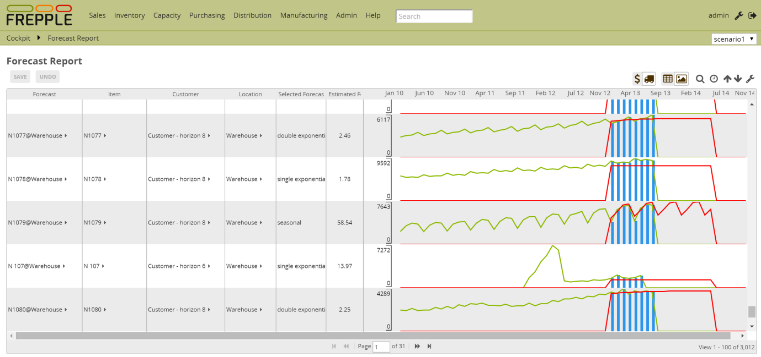

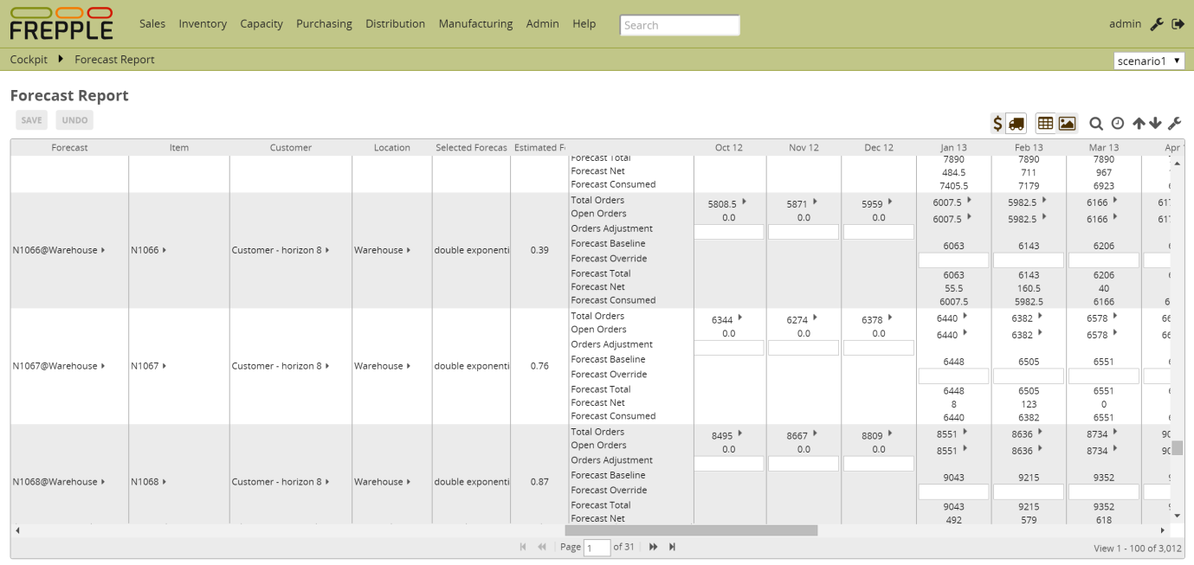

It shows the following data rows. Each row can be displayed in units or in value.

* **Orders total**This is a read-only row that is computed as the quantity available in the demand table.
* **Orders open**This is a read-only row that is computed from the data available in the demand table.
* **Orders planned**

This row show how much of the order book has been met.

* **Orders adjustment**

This row can be updated by the planner to correct demand outliers.

* **Forecast baseline**

This output row is the automatically computed forecast value by the system.

* **Forecast adjustment**

In this row the planner can enter adjustments to the baseline forecast.

* **Forecast total**

This is the sum of the forecast baseline and the adjustment.

* **Forecast consumed**

This row shows how much of the forecast has been consumed by the order book.

* **Forecast net**

This is the result of the forecast consumption. It represents the total forecast minus the demand that has already realized as customer orders.   
The sum of the rows “forecast consumed” and “forecast net” will always match the “total forecast” row.

* **Forecast planned**

In this row the planner can enter adjustments to the baseline forecast.

## Forecast editor

The forecast editor has been introduced in frePPLe with release 3,2. It allows the planner to quickly review or edit a forecast for any (Item, Customer, Location) tuple.

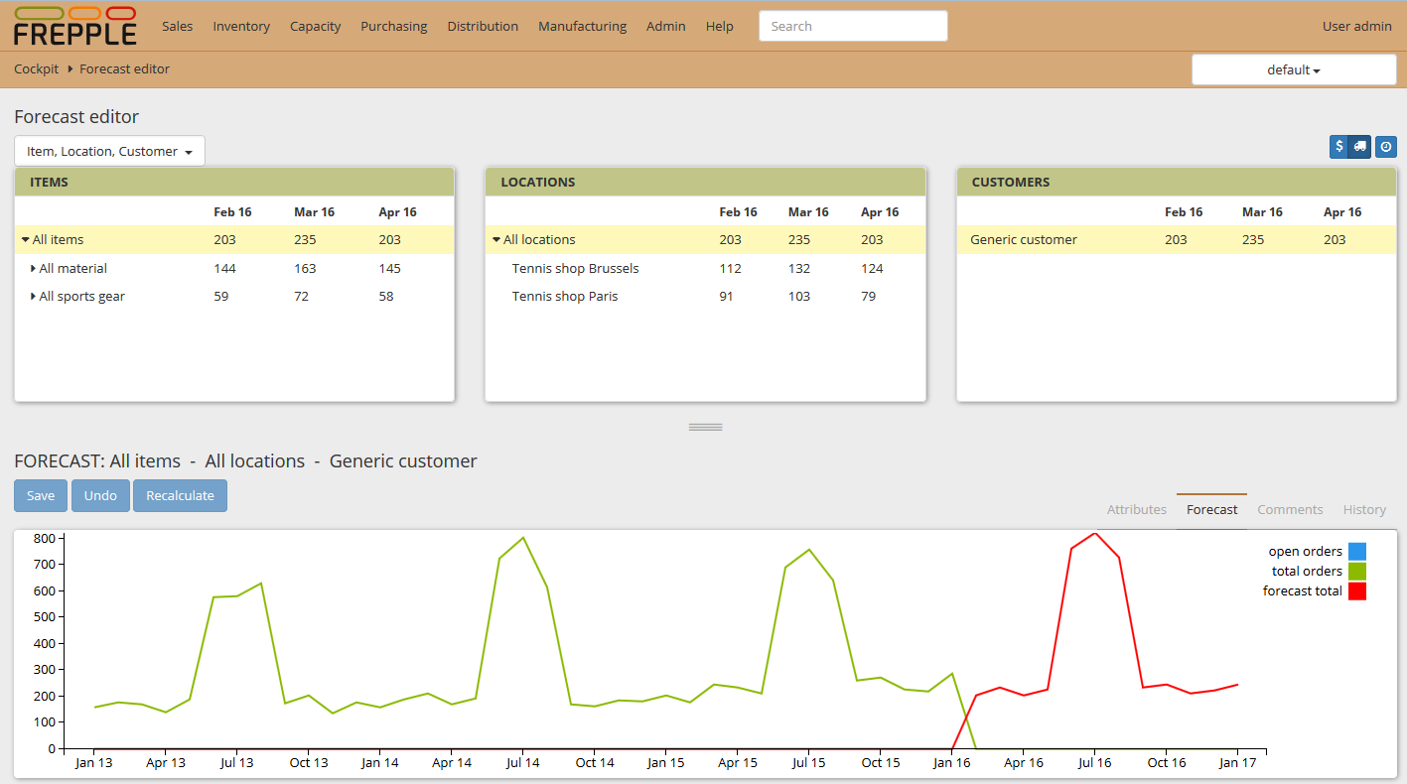

The planner will select the order he/she wants to see the dimensions in the top of the screen. All combinations are available through a drop-down menu (Items first then Locations then Customers or Locations first then Items then Customers…).

The Items, Locations and Customers screen are organized hierarchically, the planner has to select objects from the left screen to the right screen to display the combination he/she wants to see. Note that each time a selection is performed, the dimensions on the other screen are narrowed to the relevant values associated to the selection the planner performed.

Once the planner selected the right tuple in the top screen, he/she can edit the values in the grid available at the bottom of the screen. This grid is similar to the one found in the forecast report screen (see in the forecast report for the field definition). The planner can also define the forecast method he/she wants to apply to the selected tuple.

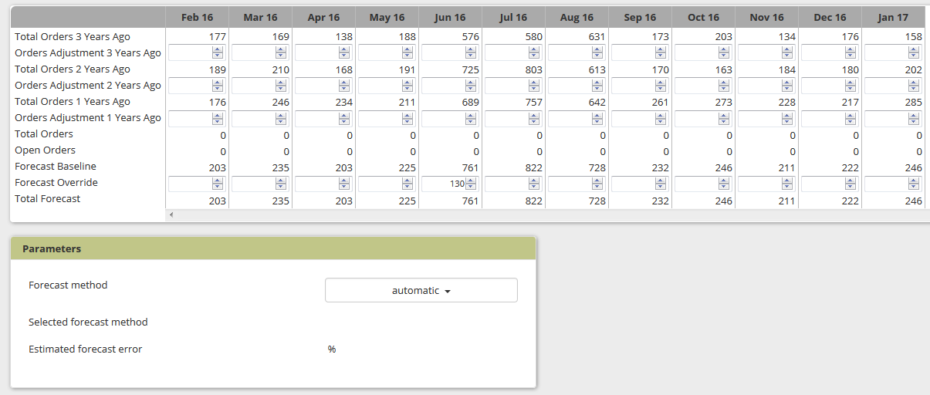

## Distribution planning screen

The distribution planning screen offers an integrated to review and update forecast and inventory planning parameters. In distribution intensive industries this is a main screen in the planner’s workflows.

The top part of the screen allows sorting and filtering on all item-location combinations. When selecting a row in the displayed list, the details are displayed in the bottom section.

The bottom section has different tabs. In the forecast tab, the planner can:

* Apply corrections to the historical demand.
* Override the forecasted value in future time buckets.
* Change the forecast method.

After a change you can hit the “recalculate” button to review the impact of the change. Once you’re confident with the change, you hit the “save” button to store the changes in the database.

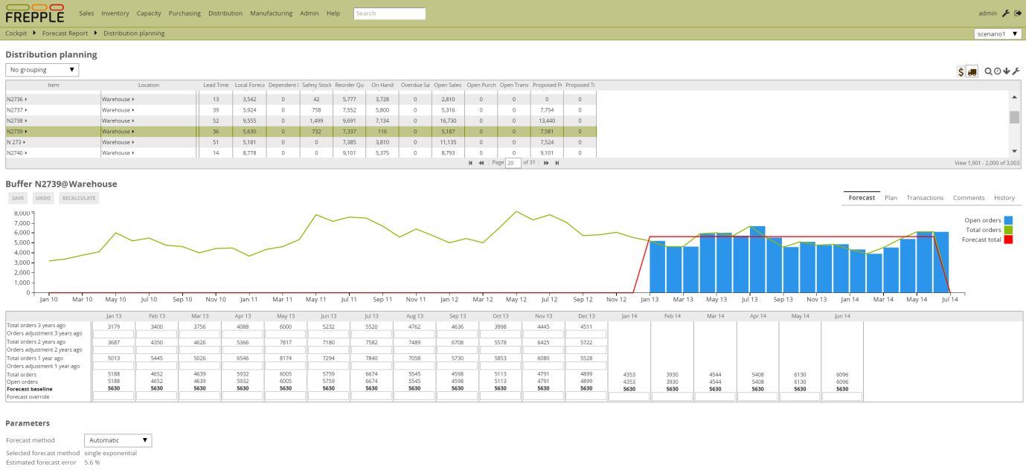

# Modelling and configuration

## Input table Forecast

This table defines the item and customer combinations where either a) forecast is computed or b) aggregated forecast data is stored.

## Input table ForecastDemand

This table is used for customers uploading forecast values that have been externally generated. Data loaded in this table will be merged into the internal frePPLe tables to store the forecast data, and after this merge the forecastdemand table is emptied.

Usage of this table is deprecated. It will be removed in a future release.

## Output table ForecastPlan

This table stores all forecast results, both in quantity and in value.

## Forecasting parameters

**Forecast consumption**

|  |  |  |
| --- | --- | --- |
| Net_CustomerThenItemHierarchy | 1 | This flag allows us to control whether we first search the customer hierarchy and then the item hierarchy, or the other way around. |
| Net_MatchUsingDeliveryOperation | 1 | Specifies whether or not a demand and a forecast require to have the same delivery operation to be a match. |
| Net_NetEarly | 0 | Defines how much time before the due date of an order we are allowed to search for a forecast bucket to net from. |
| Net_NetLate | 0 | Defines how much time after the due date of an order we are allowed to search for a forecast bucket to net from. |

**Constant forecast - Single exponential smoothing**

|  |  |  |  |
| --- | --- | --- | --- |
| **Parameter** | **Default** | **Description** |  |
| SingleExponential_initialAlfa | 0.2 | Initial smoothing constant. |  |
| SingleExponential_maxAlfa | 1.0 | Maximum smoothing constant. |  |
| SingleExponential_minAlfa | 0.03 | Minimum smoothing constant. |  |

**Constant forecast – moving average**

|  |  |  |  |
| --- | --- | --- | --- |
| **Parameter** | **Default** | **Description** |  |
| MovingAverage_order | 5 | This parameter controls the number of buckets to be averaged by the moving average forecast method. |

**Intermittent demand – Croston**

|  |  |  |  |
| --- | --- | --- | --- |
| **Parameter** | **Default** | **Description** |  |
| Croston_initialAlfa | 0.1 | Initial parameter for the Croston forecast method. |  |
| Croston_maxAlfa | 1.0 | Maximum parameter for the Croston forecast method. |  |
| Croston_minAlfa | 0.03 | Minimum parameter for the Croston forecast method. |  |
| Croston_minIntermittence | 0.33 | Minimum intermittence (defined as the percentage of zero demand buckets) before the Croston method is applied. |
| Croston_decayRate | 0.1 | If we have seen no demand hit since 2 times the average time between demands, we consider the item location as dying and start reducing the forecast value with this factor for every additional period without demand. |

**Trending forecast – double exponential smoothing**

|  |  |  |  |
| --- | --- | --- | --- |
| **Parameter** | **Default** | **Description** |  |
| DoubleExponential_dampenTrend | 0.8 | Dampening factor applied to the trend in future periods. |  |
| DoubleExponential_initialAlfa | 0.2 | Initial smoothing constant. |  |
| DoubleExponential_initialGamma | 0.2 | Initial trend smoothing constant. |  |
| DoubleExponential_maxAlfa | 1.0 | Maximum smoothing constant. |  |
| DoubleExponential_maxGamma | 1.0 | Maximum trend smoothing constant. |  |
| DoubleExponential_minAlfa | 0.02 | Minimum smoothing constant. |  |
| DoubleExponential_minGamma | 0.05 | Minimum trend smoothing constant. |  |

**Seasonal forecast – Holt-winters multiplicative method**

|  |  |  |  |
| --- | --- | --- | --- |
| **Parameter** | **Default** | **Description** |  |
| Seasonal_dampenTrend | 0.8 | Dampening factor applied to the trend in future periods. |  |
| Seasonal_gamma | 0.05 | Value of the seasonal parameter |  |
| Seasonal_initialAlfa | 0.2 | Initial value for the constant parameter |  |
| Seasonal_initialBeta | 0.2 | Initial value for the trend parameter |  |
| Seasonal_maxAlfa | 1.0 | Maximum value for the constant parameter |  |
| Seasonal_maxBeta | 1.0 | Maximum value for the trend parameter |  |
| Seasonal_maxPeriod | 14 | Maximum seasonal cycle to be checked. |  |
| Seasonal_minAlfa | 0.02 | Minimum value for the constant parameter |  |
| Seasonal_minBeta | 0.2 | Initial value for the trend parameter |  |
| Seasonal_minPeriod | 2 | Minimum seasonal cycle to be checked. |  |

**Overall parameters**

|  |  |  |  |  |
| --- | --- | --- | --- | --- |
| **Parameter** | **Default** | **Description** |  | |
| Calendar |  | Specifies the number of time series values used to initialize the forecasting method. The forecast error in these bucket isn't counted. |
| Skip | 0 | Specifies the number of time series values used to initialize the forecasting method. The forecast error in these bucket isn't counted. |
| SmapeAlfa | 0.95 | Specifies how the sMAPE forecast error is weighted for different time buckets. |
| DueAtEndOfBucket | 1 | By setting this flag to true, the forecast will be due at the end of the forecast bucket. |
| Horizon_future | 365 | Specifies the number of days in the future we generate a forecast for. |
| Horizon_history | 10000 | Specifies the number of days in the past we use to compute a statistical forecast. |
| Iterations | 15 | Specifies the maximum number of iterations allowed for a forecast method to tune its parameters. |
| loglevel | 0 | Verbosity of the forecast solver. Values are 0 (silent) through 4 (verbose debugging). |  |
| Outlier_maxDeviation | 2 | Multiple of the standard deviation used to detect and trim outliers. |  |